The Idalia Society formed in 1989 to promote the study, appreciation and conservation of butterflies, moths and other insects. Guests are always welcome! Please call OR text (816)283-6258 or contact mail@idaliasociety.org with any questions.
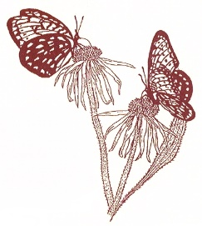

Idalia Society of Mid-American Lepidopterists
2022- IN PERSON!!!

GENERAL MEETINGS
Prairie Village City Hall--7700 Mission Rd., Prairie Village, KS 66208
The Community Center is no longer available, so we have moved across the drive to a City Hall meeting room. You can park in the same spot as before! The meeting will begin at 6:00 PM. We no longer have the space for a potluck dinner but snacks and beverages will be provided. Please bring a snack to share (optional).

SAT MARCH 12 Flora and Fauna of the Kansas Prairie
Courtney Masterson, Native Lands, LLC

SAT MAY 14 The Love Connection: Pollinators
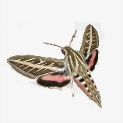
Lenora Larson, K-State Extension Master Gardener

SAT SEPTEMBER 10 Designing and Maintaining a Butterfly Garden
Paula Diaz, the Gardening Nerd

SAT NOVEMBER 12 Best Sightings of 2022 (Share your favorite insect photos!)
Field Trips
SAT JUNE 18 MOTHING!!! Potluck Dinner/Blacklighting/Prairie Exploration at Betsy Betros's House--6 PM
27622 W. 85th Terrace, Lenexa, KS 66221
SAT JUNE 25 Butterfly Garden Stroll Jack Lawless' home--4 PM 12800 Catalina, Leawood, KS 66309

SAT JULY 16 Butterfly Garden Stroll & Potluck Lunch Lenora 's home--10 AM 27995 Plum Creek Rd. Paola, KS

FRI SEPT 30 Butterfly Garden Stroll & Potluck Lunch Lenora 's home--NOON 27995 Plum Creek Rd. Paola, KS

JULY 21--AUG 7 Festival of Butterflies: Powell Gardens
TBA

BUTTERFLY COUNTS
(NOTE: A $3.00/participant fee may apply for North American Butterfly Association official counts.)

